Warning Lights & Signs on Buses

Technical Specifications

  - Information bulletin

Produced by
Registration and licencing services
Department of State Growth

GPO Box 536
Hobart Tasmania 7001

Ph: 03 6166 3263
Email: vehicle.standrds@stategrowth.tas.gov.au
Website: www.stategrowth.tas.gov.au

WARNING SIGNS AND LIGHTS ON SCHOOL BUSES TECHNICAL SPECIFICATIONS INFORMATION BULLETIN

This bulletin is a guideline only. At all-times the appropriate legislation currently in force takes precedence.

SUMMARY:
A warning sign and two warning lights must be fitted to the front, and to the rear of a bus used to carry schoolchildren outside designated urban areas in Tasmania. The following information bulletin specifies the size, location and fitment of the warning signs and lights.
Diagrams in this bulletin are not drawn to scale.

INTRODUCTION:
Warning lights and signs were introduced in Tasmania in early 1996 and their use became mandatory from the 1st of July 1996.
This Bulletin has been developed jointly by the Department of State Growth, and members of the Tasmanian Bus Association.
The specifications for warning lights and signs do not require any particular brand of light or light kit. The specifications are performance specifications and any lights which can demonstrate compliance with the performance specifications and which are fitted in accordance with the regulations are acceptable.

FITMENT REQUIREMENTS:
A bus fitted with warning lights and signs must have them fitted in accordance with the requirements of regulations as closely as practicable and to meet the operational intent.
Practicable means able to be done within the available space, method or action.

1 SPECIFICATIONS for WARNING SIGNS:
1.1. Warning Sign - Front
- Display a retro-reflective square or rectangular 40 km/h speed limit sign with the red circle having a diameter of at least 200mm centrally located on the sign, (See diagram 1) OR
- A warning sign at the front of the bus must display the words '‘SCHOOL” or “SCHOOL BUS” in capital letters at least 100 millimetres high, (See diagram 2) OR
- If using a front electronic sign that displays the destination to which the bus is travelling; the sign must display the words “SCHOOL” or “SCHOOL BUS’ in capital letters 100mm high whenever the warning lights fitted to the bus are flashing as required by the regulations.
1.2 Warning Sign – Rear
- A warning sign requirement described here may be made up of two components;
- A retro-reflective 40km speed sign (See diagram 1) and
- A sign containing the words “WHEN LIGHTS FLASH” in 60mm black letters on a white background, placed where the edges of this component is within 150mm from the edge of the 40km sign. (See diagram 3 a, b, c or d)
- A warning sign at the rear of the bus must display a retro-reflective square or rectangular, 40 km/h speed limit sign with the red circle having a diameter of at least 440mm centrally located on this section; and as part of the warning sign display the wording “WHEN LIGHTS FLASH” in 60mm black letters on a white background,
- If the words “WHEN LIGHTS FLASH” are on a single line sign, the sign shall be a minimum of 900mm long and 70mm high, with the words “WHEN LIGHTS” using the maximum even space possible between the letters of each word over a distance of 450mm and the word “FLASH” using the maximum even space possible over a distance of 450mm (See diagram 3 a), OR.
- If the words “WHEN LIGHTS FLASH” are on a single sign it must be a minimum of 300mm wide between 201mm and 440mm in height with each word centralized horizontally on a separate line of the sign in black letters on a white background, (See diagram 3 b), OR
- Where the words “WHEN LIGHTS FLASH” are made of two separate signs the words “WHEN LIGHTS” must be displayed on a sign 450mm long and 70mm high, evenly spaced with a minimum of 60mm between the words, (See diagram 3 c (i)), and
- The word “FLASH” evenly spaced on another sign 450mm long and 70mm high, (See diagram 3 c (ii)), and
- The words “WHEN LIGHTS” and “FLASH” are to be positioned one on either side, aligned with the top or bottom perimeters of the 40km sign, (See diagram 4 b).
- If the warning lights are fitted below the horizontal centre line at the rear of the bus the words “WHEN LIGHTS FLASH” must be placed immediately above the 40km sign, OR
- If the words “WHEN LIGHTS FLASH” are in two parts the words “WHEN LIGHTS” are to be on one sign 450mm long and 70mm high and the word “FLASH” on a separate sign 450mm long and 70mm high, must be placed one on either side aligned horizontally as close as possible with the top or bottom perimeter of the 40km sign, (See diagram 4 b), OR
- For a bus with a GVM up to 6000kgs:
- If the words “WHEN LIGHTS FLASH” are in two parts the words “WHEN LIGHTS” are to be on one sign 450mm long and 70mm high and the word ”FLASH” on a separate sign 450mm long and 70mm high, may be placed within 150mm above, below or to one side of the 40km speed sign, (See diagram 4 e), OR
- When the words “WHEN LIGHTS FLASH’ are made up from 3 separate signs, each sign shall be 300mm long, 70mm high, (See diagram 3 d), and
Aligned horizontally and vertically stacked with no gap between each sign, and read “WHEN” “LIGHTS” “FLASH” (See diagram 4 d)
- Where it is not possible due to the design of the bus to fit the part/s of the sign that contain the words “WHEN LIGHTS FLASH” immediately above or below the 40km sign it is permitted that the parts be fitted within 150mm of the 40km speed sign and aligned to read “WHEN LIGHTS FLASH”.
1.3 Size, Colour and Type of Warning Signs
The 40 km/h sign must be square or rectangular, and
- depict an image of the 40km/h speed limit sign of the as specified in Australian Standard AS 1743 Road Sign Specifications [Image R4-1-(40)], and
- be of the dimensional proportions specified Australian Standard AS 1743 Road Sign Specifications [Image R4-1-(40)], and
- be coated with a retro reflective material of class 1 or 2 that meets Australian Standard AS1906 (Retro- reflective Materials and Devices for Road Traffic Control Purposes)
- Front sign: red circle minimum diameter of 200mm – Located centrally on the sign.
- Rear sign: red circle minimum diameter of 440mm – Located centrally on the sign.

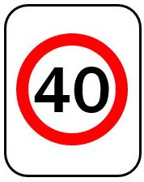
Diagram 1
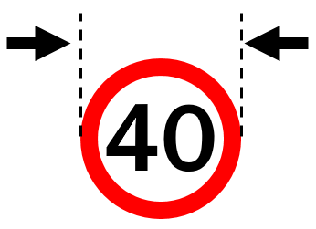
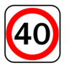

Or

Diagram 2
The SCHOOL or SCHOOL BUS warning signs at the front of the bus must be in capital letters of at least 100mm high.
SCHOOL BUS
SCHOOL

Diagram 3 showing the 4 options.
(a) single sign, straight; Minimum 900mm long by 70mm high. Lettering 60mm in height. Words “When Lights” evenly spaced over 450mm with 60mm between words. The word “Flash” evenly spaced over 450mm.
WHEN LIGHTS F L A S H

(b) single sign “stacked”; 300mm wide and between 210 and 440mm in height. Each word centralized, minimum lettering 60mm in size.
WHEN
LIGHTS
FLASH

(c) 2 sign option; each sign 450mm long, 70mm high. Words evenly spaced across full length. Words WHEN LIGHTS 60mm apart. (i) (ii)
WHEN LIGHTS
F L A S H

(d) 3 sign option; Available only for buses up to 6000kgs;
Each sign 300mm long, 70mm high with a minimum lettering of 60mm.
Aligned horizontally and vertically stacked with no gap between each sign.
WHEN
LIGHTS
FLASH

1.4 Optional wording positions:
Wording positioned with the edges of each sign within 150mm of the 40 km sign.
Diagram 4 (a) Diagram 4 (b)
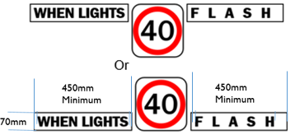
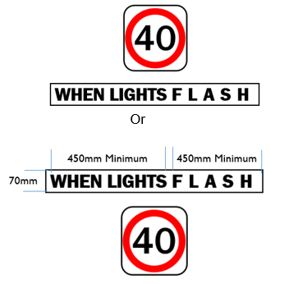

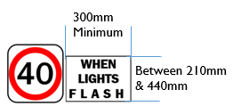
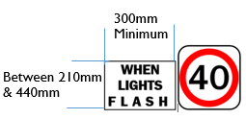
Diagram 4 (c)

Or

The following options available for buses up to 6000kgs only

Diagram 4 (d)
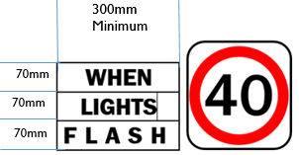
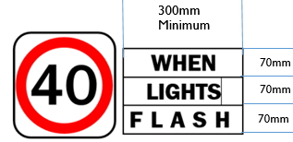

Or

Diagram 4 (e)
For this option the signs may be placed in any one of the positions shown within 150mm of the 40km sign.
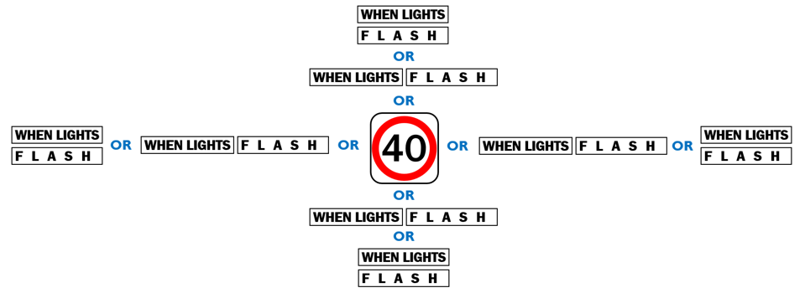

2 OPERATION AND PERFORMANCE OF WARNING LIGHTS ON BUSES
2.1 Warning Lights
- When operating, a warning light must display regular flashes of yellow light at a rate of at least 90, and not over 180, flashes a minute
- The warning lights at the same end of the bus must flash alternately
- When activated, the warning lights must operate automatically when a door on the bus opens and for at least 10, and not more than 20, seconds after all the doors on the bus has closed
- The bus must be fitted with a switch that allows the driver to turn the warning lights off
- The bus must have a visible or audible signal that tells the driver when the warning lights are operating
- A warning light must have an effective lit lens area of at least 60square centimetres
- A warning light must have a luminous intensity, in candela, of at least the values mentioned in the following table when measured at the angles mentioned in the table.

Vertical | Horizontal angle from centre of light
angle
from
centre | -30⁰ | -20⁰ | -10⁰ | -5⁰ | 0⁰ | 5⁰ | 10⁰ | 20⁰ | 30⁰
of light
10⁰ |  |  |  | 50 | 80 | 50
5⁰ |  | 180 | 320 | 350 | 450 | 350 | 320 | 180
0⁰ | 75 | 450 | 1000 | 1250 | 1500 | 1250 | 1000 | 450 | 75
-5⁰ | 40 | 270 | 450 | 570 | 600 | 570 | 450 | 270 | 40
-10⁰ |  |  |  | 75 | 75 | 75

2.2 Positional Requirements of Warning Lights
The warning lights must be fitted;
- on each side of, and the same distance from, the centre of the warning sign, (B in diagram 6) OR
- both lights are fitted above or below the warning sign (A or C in diagram 6), and
- are fitted so the centre line between the lights is within 50mm of the warning signs vertical centre, (See diagram 5) and
- the edge of the warning sign to be not over 100 millimetres from the nearest point on the lens of the warning lights, OR
- due to the design of the bus if it is not practical the edge of the warning sign to be not over 300 millimetres from the nearest point on the lens of the warning lights. (See diagram 6)
HOWEVER: if the lights on the front of the bus are mounted higher than 1.8 metres above ground level the requirement listed in B need not apply.
- the distance between the warning is lights at least 300 millimetres at the nearest point, (See diagram 6) and
- no part of the bus obstructs the light displayed;
- 30 degrees to the left and right of the centre of each light, and
- 10 degrees above and below the centre of each light.
- The warning lights may be on the warning sign if the words or image on the warning sign are not obscured.
- The warning lights at the same end of the bus must be fitted;
- at the same height, and
- as high as practicable.
- If the centres of the warning lights are under 1.80 metres above ground level, no part of the warning lights or warning sign may be on the left of the bus.
- Warning lights may be mounted on brackets or flush mounted into the bus or may be affixed to the inside of bus windows.
- Lights must not be mounted behind tinted glazing, as this will reduce their luminous intensity.
- Warning lights and signs must not interfere in any way with the operation of emergency exits.
- The fitting of the warning lights and signs applies to a bus despite any requirement of a Third Edition ADR. Warning lights must be fitted symmetrically (eg AA, BB or CC. See diagram 6)

Diagram 5 Diagram 6
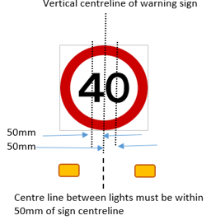
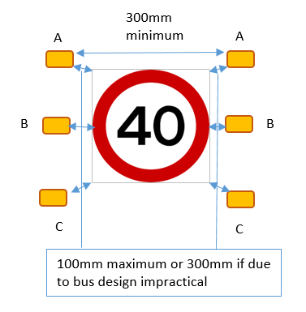

When warning lights are fitted to the inside of the windscreen ensure the following;
Signs may be affixed within the top 10% of the windscreen if they do not obstruct the driver’s view of the road, are not fitted behind tinted glazing and are not fitted below the swept path of the windscreen wipers
Guidance note: Some buses (eg Toyota Coaster) may have lights and signs fitted at the top of the windscreen within the swept path of wipers if it is not practical for them to fully comply. This recognises that it is far more effective to fit lights and signs at the top, rather than the bottom of the windscreen
If located at the bottom of the windscreen lights should not obstruct the driver’s view or heater demister operation
If located at the bottom of the windscreen then the sign must be placed below the lights. The sign must not cover any of the lower part of the windscreen
When warning lights are fitted to the inside of a rear window ensure that the lights cannot be tampered with by occupants sitting in the back row of the bus.

FURTHER INFORMATION:
For further information contact the Vehicle Standards,
Department of State Growth,
GPO Box 536,
Hobart, 7001
Tasmania.
Ph: 03 6166 3263

Department of State Growth
GPO Box 536
Hobart TAS 7001
P 03 6166 3263
www.stategrowth.tas.gov.au

