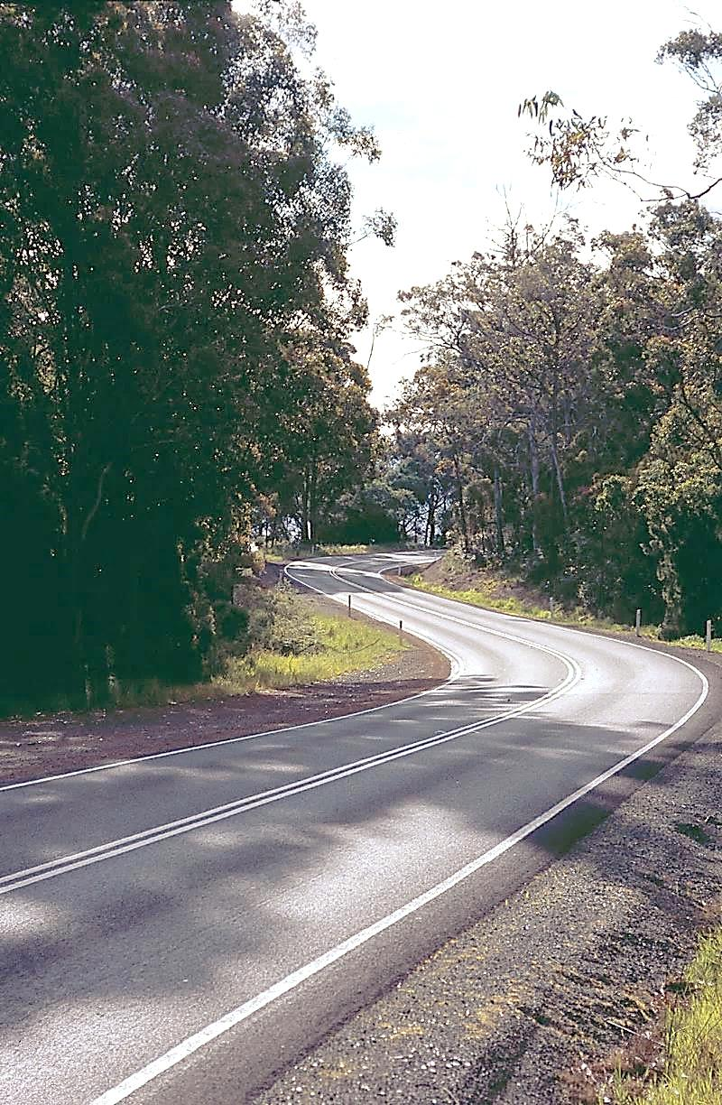

**TRANSPRTER**



Department of State Growth



**JANUARY 2016**

**IT’S A NEW YEAR!**

2015 has come to an end, and the New Year is upon us bringing with it some lovely, summery weather! Hopefully you and your families had a wonderful Christmas break and took the time to enjoy some relaxation in the sun. We look forward to working together with you to make 2016 another successful and rewarding year.

**CHANGES TO STUDENT FARES 2016**

As recently advised, effective 1 January 2016 the maximum cost of a child student bus fare will be $1.60 for a single trip.

All fare-paying services will be required to offer a minimum of 20% discount on the student fare. This should be provided in the form of a 10-ride ticket, or where an electronic ticketing system is in place, a 20% discount when using a Greencard/Smartcard.

**NEW TOP-UP CLAIM FORMS**

The new student fare structure has necessitated a change to the top-up claim form for fare-paying services. By now you should have received a copy of the updated form which includes a column for Discounted Student Fare. This column is for students who use a 10-ride ticket or where they purchase a fare through an electronic ticketing system. Any student not accessing the discounted fare should be recorded under the Full Student Fare category.

From 1 January 2016, all fare-paying services should submit a top-up claim using the new form.

In 2016 we plan to introduce the submission of online top-up claims, beginning with General Access services initially and then rolling out to all other fare-paying services.

**STUDENT GREENCARDS**

Please be aware that Student Greencards are no longer required for non-Metro fare-paying students. All students with a free pass entitlement will still be required to present the driver with a Student Greencard to access free travel.

Non-Metro free Student Greencards will be issued with an expiry year displayed on the front of the card to identify their free travel entitlement.

Fare-paying operators please be reminded that students no longer need to tap a card on the Black Box system, nor will drivers have need to use a Mastercard.

**REVISED BUS PASS APPLICATIONS**

As a result of changes to Student Greencard requirements, the online application system has been updated for both New/Renew and Replacement bus passes. Those students who are eligible to apply for a free bus pass, should access the online application system at [www.transport.tas.gov.au/passenger/student_travel](http://www.transport.tas.gov.au/passenger/student_travel)

**BACK TO SCHOOL ROAD SAFETY CAMPAIGN**

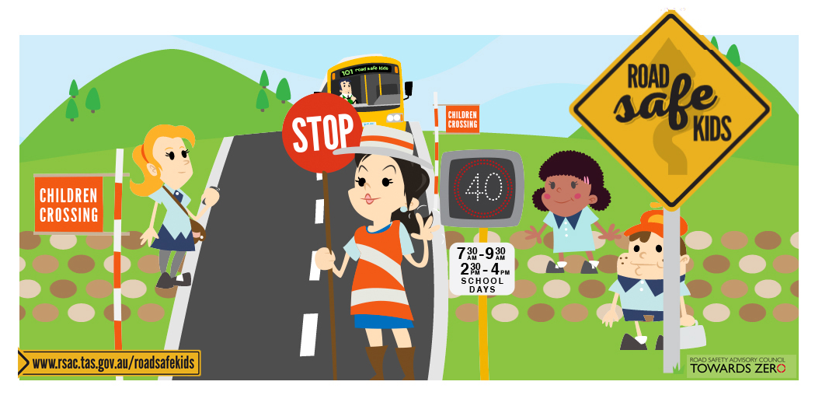

**STOP, LOOK, LISTEN & THINK**

When school starts in February, about 30,000 primary and secondary students a day will travel to and from school using a school bus.

Travelling by bus is seven times safer than travelling in the family car, but children are up to four times more likely to be involved in a road crash when getting on and getting off the school bus and crossing busy roads.

Children are vulnerable because they lack judgement on estimating the speed and direction of vehicles. They are also more impulsive and take greater risks.

You will notice a new television commercial and website ([www.rsac.tas.gov.au/roadsafekids](http://www.rsac.tas.gov.au/roadsafekids)) that encourages students to **Stop, Look, Listen, Think** before crossing the road when school returns and throughout the year.

To further encourage students to be safe, a new version of the **Stop, Look, Listen, Think** bus safety sticker will be sent to you.

**APPROVAL OF BUS CHANGES**

Prior to the implementation of any vehicle change, all operators need to obtain approval from the Department PRIOR TO purchasing a new/second-hand vehicle.

This will ensure the vehicle complies with all applicable contractual and legislative requirements and will prevent issues arising when attempting to add the vehicle to a contract.

One significant requirement of note; all operators purchasing a bus to be used on a Rural School Bus service, please be aware that standing capacity is essential on all vehicles where the bus has a seating capacity of 25 or more.

**CAPITAL RATES**

The Capital Payment rates have been calculated for the quarter commencing

January 2016. Please consider these rates before making changes to your contract.

For all fare-paying operators the rates applicable to your monthly contract payment can be found on your Statement of Payment.

|  |  |  |
| --- | --- | --- |
|  | OCT 2015 | JAN 2016 |
| Urban Fringe Student Only | **$1.67** | **$1.70** |
| Rural Fare Paying | **$1.67** | **$1.70** |
| Long Distance Student Only | **$1.67** | **$1.70** |
| Long Distance General Access | **$3.16** | **TBA** |
| Urban Fringe General Access | **$3.16** | **TBA** |
| Urban | **$0.92** | **$0.92** |
| Town | **$0.92** | **$0.92** |

**BUS COST MODEL INDEX (BCMI)**

The BCMI has been calculated for January 2016 and is 118.3.

**NON-COMPLIANCE NOTICES**

Using the Black Box tracking system, the Department is now conducting regular monitoring to ensure that all services are operating to their contracted route and timetable.

The performance standards in the New Service Contract state that delivered journeys must follow the approved route at all times for the relevant service.

Please be advised that we will be issuing non-compliance notices for any service found to be operating contrary to the conditions of the contract. This may result in a reduction in performance payments and the recording of non-compliance incidents.

**WORKING WITH CHILDREN**

Please be aware that all school and general access bus drivers that hold an ancillary certificate to drive a public passenger vehicle will also be required to hold Registration to Work with Vulnerable People (WWVP) from 1 April 2016.

The processing time for WWVP applications is six weeks, so please encourage your drivers to apply by mid-February 2016 to ensure that they can continue to drive beyond 1 April 2016.

Applications can be made online via the Department of Justice website: <http://www.justice.tas.gov.au/working_with_children/application>

**STAFF UPDATE**

In early December 2015, after 3 years in his role as Manager of Passenger Transport and Delegate of the Secretary, Martin Grace departed for greener pastures in the north of the state. We wish him all the best in his new adventures. Babette Moate, whom many of you may already know, has now stepped into the position and we are very excited to welcome her to the team.

As you may be aware, our Black Box guru Trish Reardon has been on 12 months maternity leave. She has now returned from leave and is available to help with all your Black Box queries. Her temporary replacement, Rik Considine, has now returned to his Traffic Systems role, and home, in Launceston.

**NEW FAX NUMBER**

Please be advised that effective 1 January 2016 any fax correspondence intended for Passenger Transport will need to be directed to the new fax number (03) 6173 0260.

**CONTACT US**

Should you have a query for any member of the Contracts team, please don’t hesitate to get in touch with us:

|  |  |  |  |
| --- | --- | --- | --- |
| Babette Moate | Manager | 6166 3332 | [babette.moate@stategrowth.tas.gov.au](mailto:babette.moate@stategrowth.tas.gov.au) |
| Andrew Mullen | Manager Contracts | 6166 3343 | [andrew.mullen@stategrowth.tas.gov.au](mailto:andrew.mullen@stategrowth.tas.gov.au) |
| Craig Elliot | Principal Contracts Officer | 6166 3334 | [craig.elliot@stategrowth.tas.gov.au](mailto:craig.elliot@stategrowth.tas.gov.au) |
| Kim Harris | Senior Contracts Admin | 6166 3340 | [kim.harris@stategrowth.tas.gov.au](mailto:kim.harris@stategrowth.tas.gov.au) |
| Lauren Stewart | Payments | 6166 3336 | [lauren.stewart@stategrowth.tas.gov.au](mailto:lauren.stewart@stategrowth.tas.gov.au) |
| Andy Hall | Contracts Admin | 6166 3342 | [andrew.hall@stategrowth.tas.gov.au](mailto:andrew.hall@stategrowth.tas.gov.au) |
| Geoff Reason | Contracts Admin | 6166 3341 | [geoffrey.reason@stategrowth.tas.gov.au](mailto:geoffrey.reason@stategrowth.tas.gov.au) |
| Lisa Cairns | Bus Passes | 6166 3333 | [lisa.cairns@stategrowth.tas.gov.au](mailto:lisa.cairns@stategrowth.tas.gov.au) |
| Trish Reardon | Project Officer | 6166 3347 | [trisha.reardon@stategrowth.tas.gov.au](mailto:trisha.reardon@stategrowth.tas.gov.au) |