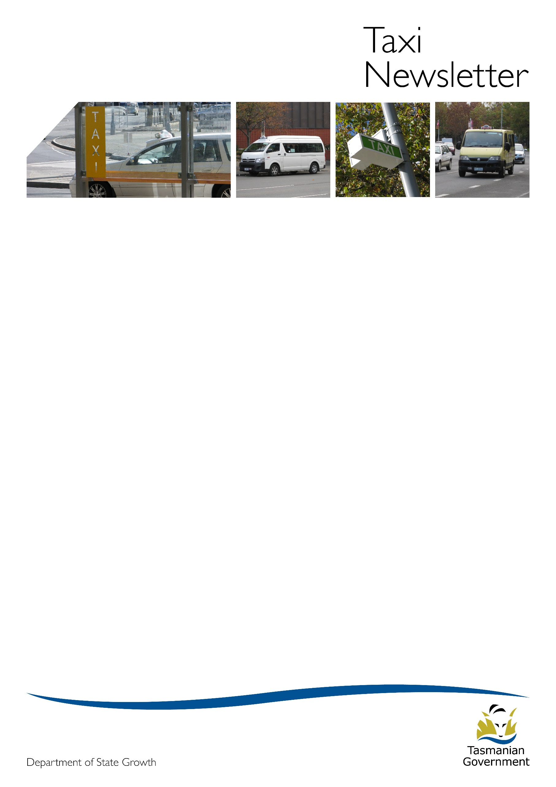

Issue 90

March 2021

Taxi Fare Increase

Taxi fares have increased. A five percent increase took effect on 25 February 2021.

Taxi Meters must be tested after reprograming for new fares.

If your meters have not been tested, please ensure they are tested as a matter of urgency.

A list of authorised taximeter adjusters is available on the Transport Tasmania website or by [clicking here](https://www.transport.tas.gov.au/public_transport/industry_and_operator_information/taxi,_hire_vehicles_and_ride_sourcing/taxi/taximeter_adjusters_-_approved_taxi_equipment)

After the taximeter has been tested:

* The authorised taximeter adjuster will give you a certificate as evidence that the taximeter is charging the correct fares. You must keep this certificate with your records, and produce it if required to the Transport Commission.
* Two fare labels applicable to the taxi area must be placed in each of your taxis to help passengers understand the amount of taxi fares they will be charged.

# Annual administration fee for taxi and luxury hire car licences

With the introduction of the new On-Demand Passenger Transport Services Industry Act 2020, the annual administration fee for taxi and luxury hire car licences will be changing. Work is currently underway to introduce these changes. As such the collection of the existing administration fee which is usually due on 1 April each year will not be occurring.

The Department of State Growth will provide more information about consultation with industry on the new accreditation fee soon.

Taxi Areas

Taxis can only be operated to, from or within the taxi area to which their taxi licence relates. A taxi driver is not allowed to accept a hiring which starts and finishes outside their taxi area.

It is important that you are familiar with the boundary of your taxi area.

The Department of State Growth has published a map of taxi areas in Tasmania on the Transport Tasmania website. You can view it by [clicking here](https://maps.stategrowth.tas.gov.au/portal/apps/webappviewer/index.html?id=db009fc38032428885d535bf7ab3c26d)

You can zoom in on the map for detail of taxi area boundaries.

The rules about taxi areas make it fair for everyone. If you are concerned that someone may be breaking the rules you can email [operator.accreditation@stategrowth.tas.gov.au](mailto:operator.accreditation@stategrowth.tas.gov.au) with the details of the event.

State Growth takes complaints about breaches of regulations very seriously and will investigate the matter.

Driver Behaviour

Assistance Animals

Some people living with disability use assistance animals (also known as service animals).

Assistance animals include:

* Dogs trained to perform personal care tasks (carrying items, opening doors) or mobility assistance (pulling wheelchairs or aiding balance) for people with physical conditions including cerebral palsy, multiple sclerosis or suffering the impact of a serious accident;
* Guide dogs to assist people with vision impairment to move around safely;
* Hearing dogs to alert people with hearing impairment;
* Medical alert dogs (such as for the detection of impending seizures in people with epilepsy or blood sugar changes in people with diabetes); and
* Psychiatric service dogs to reduce anxiety, alert to triggering situations, provide routine, and improve communication and social interaction for people with Post Traumatic Stress Disorder (PTSD), mental health problems, brain injury, dementia or autism.

It is mandatory for taxi drivers to carry passengers with assistance animals. Refusing a fare because the passenger has an assistance animal is against discrimination and taxi laws.

As an operator you have an important role to:

* tell drivers they can’t refuse a fare because a person has an assistance animal.
* educate drivers of their right to enquire respectfully into the qualifications of a passenger’s assistance animal; and
* ensure drivers are aware of, and adhere to their obligations about assistance animals.

For more information contact the Regulations Team.

A Message from Guide Dogs Tasmania

Guide Dogs and Guide Dogs in Training have full public access.  Drivers must allow a person accompanied by a Guide Dog or Guide Dog in Training into your taxis and not direct a person accompanied by a Guide Dog or Guide Dog in Training to leave the vehicle on account of the Assistance Animal.

Drivers cannot deny service to a person accompanied by a Guide Dog or Guide Dog in Training. Penalties apply and civil action could also be taken.

From eight weeks of age, the dogs in our Guide Dogs Tasmania program are socialised in public areas. They are quiet, well-behaved, non-aggressive, toilet trained, and completely clean.

If drivers refuse a Guide Dog or Guide Dog in Training handler entry to your taxi, then the driver is discriminating against that individual because of their disability, and the driver is breaking the law.

A working Guide Dog will be wearing a harness, and a Guide Dog in Training will be wearing an orange training coat (see photos below).

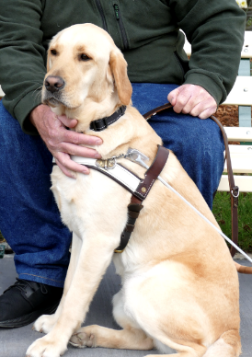Please remember that Guide Dogs can go anywhere. Thank you for your support.

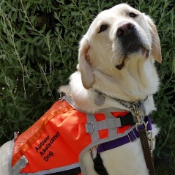

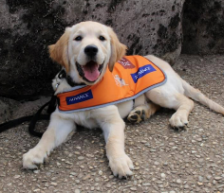Left to right: Guide Dog in Training, Guide Dog, Autism Assistance Dog

Taxi Ranks

There are rules around the use of taxi ranks. Let your drivers know they must:

* not refuse to accept a hiring when on a taxi rank (unless they fear for their safety);
* move the taxi to the first vacant space available within the rank;
* not prevent another taxi from leaving a taxi rank;
* not to tell a person that they must hire the front taxi on the taxi rank; and
* not leave the taxi parked unattended on a taxi rank.

Leaving a taxi unattended on a rank without reasonable excuse is an offence, even when a ‘not for hire’ sign is displayed.

If you, or one of your drivers witness driver behaviour which you believe is illegal, please report it to Tasmania Police.

You may also consider providing information to the taxi network of the driver who is acting illegally.

The Transport Commission

As an Operator it is important you keep the Transport Commission up to date in relation to your service. The Commission must be able to contact you if necessary and provide you with information relevant to your service. For this reason, keep your contact details up to date.

Further, it is important that you contact the Commission yourself if there is any important event that you must inform us about. For example, you must inform us (within 14 days) if you are charged with a serious offence or if the responsible person for the accreditation changes.

Facemasks in taxis

Facemasks should be carried in every taxi.

Facemasks must be worn at all times when outside a vehicle at Tasmanian airports.  The current Tasmanian public health direction requires:

* All persons aged 12 and older who are at a Tasmanian airport must wear a facemask.
* Carry a facemask with you anytime you intend to visit an airport and wear it as required.
* This applies across all Tasmanian airports.

Facemasks are encouraged to be worn by drivers of small passenger transport vehicles being used to transport passengers to a COVID drive-in testing facility or when transporting passengers with cold or flu-like symptoms such as fever, shortness of breath, a cough or a sore throat to medical appointment.

Disposable masks should not be reused and should be disposed of immediately after removing, or where this is not practicable,  placed in a plastic bag and sealed until they can be disposed of.

See the attached fact sheet for more information on the requirement to wear masks at airports.

Hand sanitiser should be used before and after a handling a mask or having direct contact with passengers and their luggage.

Accreditation Certificate

Remember that your accreditation certificate must be:

* kept and stored as part of your accreditation records;
* displayed prominently in every taxi used for your service, and
* produced on demand to a Police Officer or a Transport Safety Investigation Officer.

It is an offence and you could be issued a fine for not having your accreditation certificate in your vehicle.

It is important to remove your accreditation certificate from your taxi when you sell the vehicle as unaccredited operators may try to use your certificate to operate illegally.

# COVID-19

To keep up to date with the latest information and advice go to [coronavirus.tas.gov.au](https://coronavirus.tas.gov.au/).

# Regulations and Concessions Unit

Contact us by e-mail [operator.accreditation@stategrowth.tas.gov.au](mailto:operator.accreditation@stategrowth.tas.gov.au).