|  |  |  |  |  |  |  |  |  |  |  |  |
| --- | --- | --- | --- | --- | --- | --- | --- | --- | --- | --- | --- |
| **Registered operator name** |  | | | | | | **Address** | |  | | |
| **Registration Number** |  | | | **Vehicle Make & Model** | | | |  | | | |
| **Gross Combination Mass** (KG)  (GCM must be recorded for the vehicle prior to issue of the permit, refer declaration below*) | | |  | | **Trailer Axles**  (Maximum number of trailer axles intending to tow with the vehicle at any one time under the use of this permit) | | | | | |  |
| **Start date of permit** | |  | | | | **End Date of permit** | | | |  | |

|  |  |  |  |  |  |
| --- | --- | --- | --- | --- | --- |
| **Current Classification** |  | **Requested Classification (X)** | | | |
| **1R2 or 2R2** |  | **SR2** | | **SP2** | |
| **1R3 or 2R3** |  | **SR3**    No more than 6 axles in total and operating up to 42.5t | **MR3**  More than 6 axles or operating at over 42.5t | | **SP3** |
| **1R4 or 2R4** |  | **SR4**    No more than 6 axles in total and operating up to 42.5t | **MR4**    More than 6 axles or operating at over 42.5t | | **SP4** |
| **Prime Mover for B Double** |  | **MC2** | **MC3** | | **MC4** |

|  |  |  |  |
| --- | --- | --- | --- |
| **Does the change in classification require modification?***(Check requirement guide on page 2)* | **No** | **Yes** | **Modification**  **plate number\*** |

|  |
| --- |
| **I Declare and understand that:**   * Permits are available for periods of 1-90 days, providing registration does not expire within this period. * *A vehicle must have a GCM recorded prior to issue of the permit. **If the GCM is not recorded for the registration record you** must provide evidence of the GCM by providing a photo of the 'Identification' or 'Modification' Plate. You can check if the GCM is recorded by reviewing your registration certificate. * *Modification Plate number or Manufacture Plate number **must** be provided when modification required. * It is the registered operator’s responsibility to provide correct details and ensure appropriate manufacturers ratings on all equipment. * It is an offence to tow a trailer where the combination laden mass of the truck and trailer exceed the GCM of the truck and **it is the operator’s responsibility to ensure that the permit vehicle has a GCM within the range of the upgraded configuration.**   **Signature Date** |

Page 1 of 2

**J & P Modification - Requirement Guide**   
 **Use this chart to determine if alteration to vehicle configuration requires certification.**Use whichever axis aligns to the corresponding box, be it from the horizontal or the vertical it does not matter. If there is a tick then modification approval is required, if there is a cross then no modification approval is required.

Applies to all changes to body types/towing couplings on Heavy Vehicles from 01 July 2015, if not already certified.

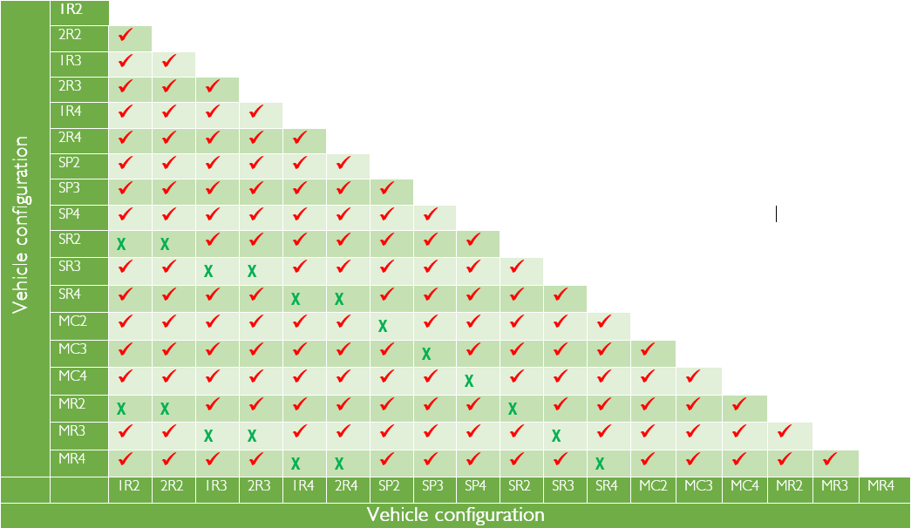

|  |  |
| --- | --- |
| Key | Action Required |
| ᵡ | Vehicle classification or upgrade **does not require** certification. No modification or certification is required to issue the permit or process a vehicle configuration change. |
| ✓ | Vehicle classification or upgrade **requires** a modification or manufacturers plate to be affixed to the vehicle identifying the type of modification and when it occurred. Customer will need to supply a valid modification or manufactures plate number or undertake an inspection. See [Approved Inspection Stations – Heavy Vehicle](http://www.transport.tas.gov.au/vehicles/vehicle_inspections/ais/ais_locations/approved_inspection_stations_-_heavy_vehicle) for inspection locations. |

Page 2 of 2