INNOVATION
Department of State Growth
MAKING OUR ROADS SAFER

Responding to the Situation

Conditions on Tasmania’s roads change frequently. There are a range of innovations either already in place or coming soon to alert drivers to possible hazards.

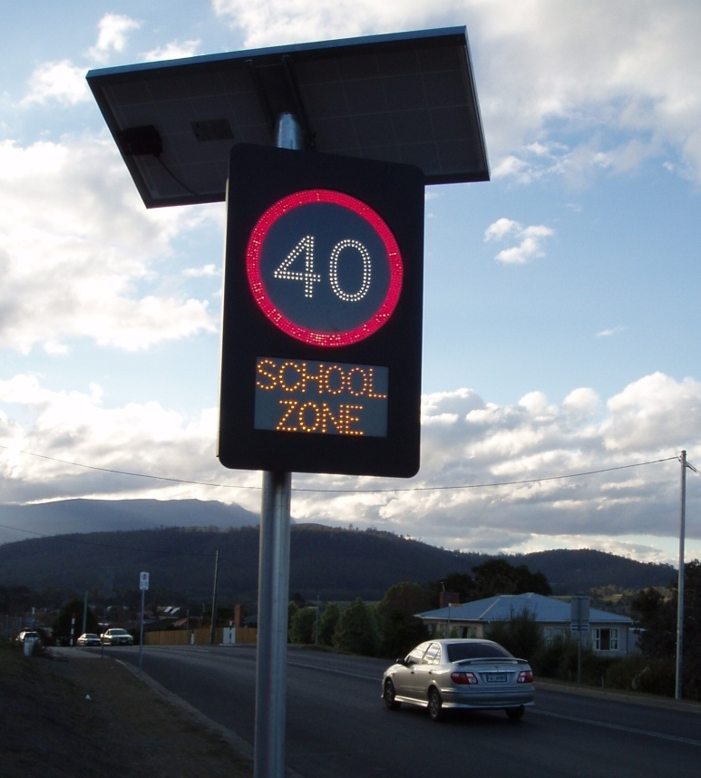 |  | School Zones  Speed signs around Tasmanian schools are being replaced with electronic signs. The new signs use high visibility LEDs and operate for set times on school days only. This helps remove confusion about when the zone is active and encourages drivers to slow down.
Shopping Zones
Slowing traffic through busy shopping zones can have great safety benefits, especially for pedestrians. An electronic sign sets a lower speed limit during the busy times and returns it to the normal speed limit the rest of the time. Look out for one on Main Road, Moonah, coming soon.
High-Speed Roads
Crashes on busy high-speed roads can cause significant disruption. Slowing traffic down in response to changing conditions improves safety and traffic flow. A variable speed limit system uses electronic signs to change the speed limit to match the situation. This might be a crash, an obstacle on the road, a queue of vehicles during peak times, or weather such as rain, ice, or wind. Look out for a variable speed limit zone coming soon to the Tasman Highway, Hobart.

