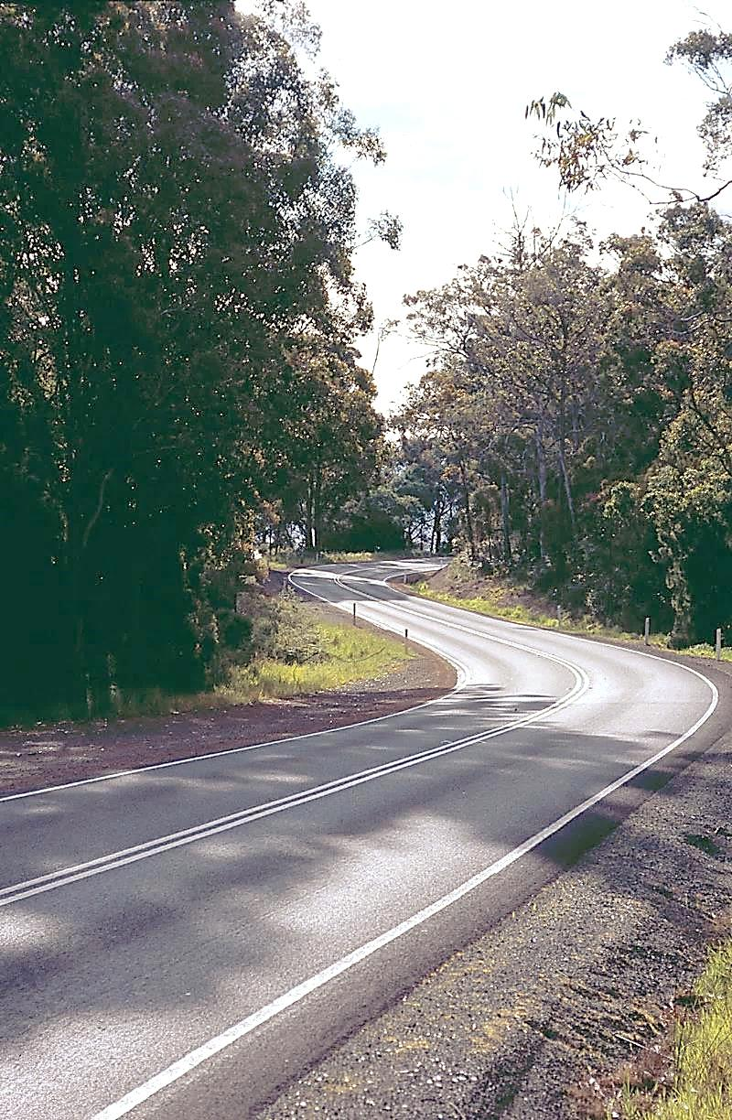

**TRANSPRTER**



Department of State Growth



**OCTOBER 2014**

**MERRY CHRISTMAS!**

It’s nearly that time of year already! As this will be the final newsletter for 2014, we want to wish you all a very happy and safe holiday period. We are looking forward to an innovative and exciting 2015!

**GREENCARD TRAVEL 2015**

****With fourth term now underway, the 2015 Student Greencard processing period is fast approaching. Students who currently hold a FREE travel Greencard with an expiry year of 2014 will need to submit a New/Renewal Student Greencard application for next year. The students affected will soon receive a letter reminding them to reapply.

Applications for 2015 can be submitted from 15November 2014, and if received by 2 January 2015 the Department will issue the new cards before school returns in 2015. Applications received after 2 January 2015 will be processed as soon as possible.

There are two ways students can apply for a New/Renewal Student Greencard:

1. Online at [www.transport.tas.gov.au](http://www.transport.tas.gov.au)
2. Obtain a paper application from Service Tasmania Shops or download an application from our website

**LOST/DAMAGED OR STOLEN STUDENT GREENCARDS:**

All FREE travel Student Greencards (excluding Metro-only FREE travel) that have been lost, damaged or stolen can now be replaced at Service Tasmania shops for a fee of $11, including home area, care and protection and concession card holders.

Those with concession card FREE travel eligibility also have the option to obtain a replacement online at [www.transport.tas.gov.au](http://www.transport.tas.gov.au).

All Metro-only FREE travel Student Greencards must be replaced through Metro.

AllFARE PAYING Student Greencards that have been lost, stolen or damaged must be replaced through Metro for a fee of $5.

**MORE INFORMATION:**

Prior to 15 November 2014, the Department will be issuing information posters to all Student Only Fare Paying operators to display on your bus/es. If you require any further information, please contact the Student Travel Officers – Lisa Cairns on 6166 3333 or Geoff Reason on 6166 3341.

**REPLACEMENT VEHICLES**

When advising the Department of a replacement vehicle, please ensure you provide the following information:

* Contract number
* Registration of the current bus
* Registration of the replacement bus
* Black Box IVU serial number to be removed from the current bus and installed in the replacement bus (where applicable)
* Mastercard number of the current bus to be transferred to the replacement bus (where applicable)
* Date when the replacement bus will start being used on the service

Once the replacement bus has been registered we will reimburse the Duty portion of the registration costs. If you have purchased your replacement bus from the mainland we will also reimburse your shipping costs for the freight across Bass Strait.

Please forward your registration paperwork and paid shipping invoice to the Department either by fax on 6233 5377 or email at [ptscontracts@stategrowth.tas.gov.au](mailto:ptscontracts@stategrowth.tas.gov.au)

**BP FUEL CARDS**

In accordance with the Bulk Fuel Purchase Scheme arrangements, the annual administration fee of $25 will be deducted in November. You would have recently received a list of the active cards in your possession and hopefully have returned this, with any amendments, to ensure the correct amount is deducted.

As a reminder to all participants, the agreement allows for two vehicles per contract to obtain a BP Fuel card. These two vehicles must be directly engaged in Student Regular Passenger Transport Services to access the government bulk fuel discount.

If you change a vehicle on your contract, you will also need to have the corresponding BP Fuel card replaced. You can do this at the time of advising the Department of your replacement vehicle.

(Note: The State Government Fuel Contract is due for renewal soon. We will advise of any updates when information becomes available.)

**BUS COST MODEL INDEX (BCMI)**

The Bus Cost Model Index (BCMI) reported on the September 2014 payment remittance advice was not updated from the previous month. Please be advised the remittance advice should have read:

BCMI for August – 119.8

BCMI for September – 119.6

We apologise for any inconvenience this may have caused.

The BCMI for October 2014 has now been calculated and is 119.4

**CAPITAL RATES**

The Capital Payment rates have been calculated for the quarter commencing October 2014. Please consider these rates before making changes to your contract.

For all fare-paying operators the rates applicable to your monthly contract payment can be found on your Statement of Payment.

|  |  |  |
| --- | --- | --- |
|  | JUL 2014 | OCT 2014 |
| Urban Fringe Student Only | **$1.49** | **$1.49** |
| Rural Fare Paying | **$1.49** | **$1.49** |
| Long Distance Student Only | **$1.49** | **$1.49** |
| Long Distance General Access | **$3.09** | **$3.09** |
| Urban Fringe General Access | **$3.09** | **$3.09** |
| Urban | **$0.95** | **$0.95** |
| Town | **$0.95** | **$0.95** |

**TRANSPORT WEBSITE**

The recent change to the Department of State Growth has required an update of our website. If you have your own website that contains links to the Departmental site, please ensure the links and information you provide are up to date.

If you require further clarification, please contact Trisha Reardon on 6166 3347 or [trisha.reardon@stategrowth.tas.gov.au](mailto:trisha.reardon@stategrowth.tas.gov.au)

**STAFF UPDATE**

The Contracts team has experienced further change over the past few months – Mandy Brown has now left the Department and taken a permanent position with the Premiers Office. Her role of Senior Contracts Administration Officer will be undertaken on a temporary basis by Kim Harris, who has been doing a stellar job in her absence.

Should you have a query for any member of the Contracts team, please don’t hesitate to contact us:

Martin Grace 6166 3332 [martin.grace@stategrowth.tas.gov.au](mailto:martin.grace@stategrowth.tas.gov.au)

Andrew Mullen 6166 3343 [andrew.mullen@stategrowth.tas.gov.au](mailto:andrew.mullen@stategrowth.tas.gov.au)

Kim Harris 6166 3340 [kim.harris@stategrowth.tas.gov.au](mailto:kim.harris@stategrowth.tas.gov.au)

Lauren Stewart 6166 3336 [lauren.stewart@stategrowth.tas.gov.au](mailto:lauren.stewart@stategrowth.tas.gov.au)

Andy Hall 6166 3342 [andrew.hall@stategrowth.tas.gov.au](mailto:andrew.hall@stategrowth.tas.gov.au)

Lisa Cairns 6166 3333 [lisa.cairns@stategrowth.tas.gov.au](mailto:lisa.cairns@stategrowth.tas.gov.au)

Geoff Reason 6166 3341 [geoffrey.reason@stategrowth.tas.gov.au](mailto:geoffrey.reason@stategrowth.tas.gov.au)

Effective 10October 2014 the Passenger Transport Services Branch has relocated to Level 8, 10 Murray Street, Hobart.