INNOVATION
Department of State Growth
MAKING OUR ROADS SAFER

Traffic Signals – Getting the Green Light

We’re all familiar with traffic lights, but did you know…
from this | The Lights are Changing | to this
Tasmanian traffic signals are gradually being upgraded to LED lights, providing safety, environmental and cost benefits.
LED lights are easier for drivers and pedestrians to see in all light conditions and use 85% less power than normal lights.
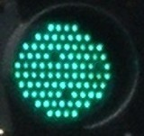
They last a long time and gradually fail rather than suddenly burn out. This allows them to be replaced before the traffic light stops working altogether.

Taking Turns
Traffic signals can be used to balance flows at roundabouts where large volumes of traffic from one approach cause excessive queuing on another approach. To help smooth traffic flow, vehicles are stopped at a red light to allow the queued vehicles to enter the roundabout. When the queue has reduced, the red light turns off and the roundabout goes back to normal operation.
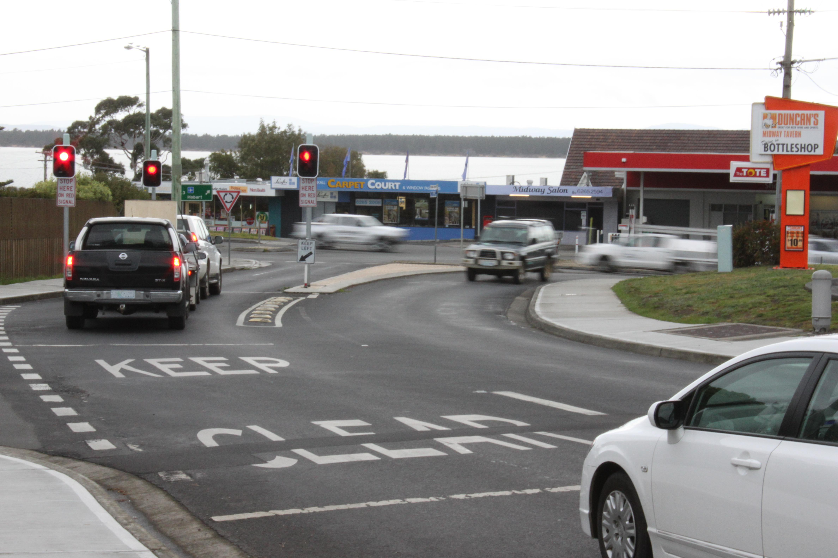

You can see this in action at the Midway Point roundabout between 7.00-9.00am
Monday-Friday.

