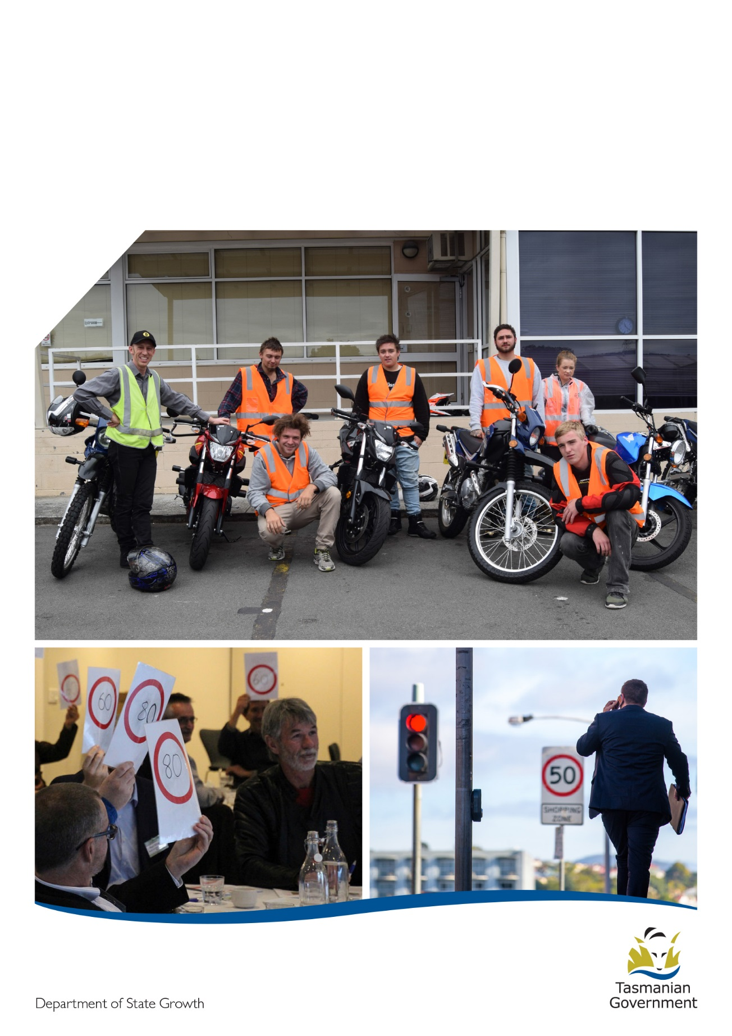

Guidelines
  - Community Road Safety Grants
Contents
Overview 2
Road safety in Tasmania 2
Eligibility 3
Assessment criteria 6
Assessment process 7
Funding 7
Key dates 8
How to apply 8
Successful applicants 9
Further information 10

Overview
The Road Safety Advisory Council (RSAC) offers funding to community groups for community initiatives that work to address road safety issues. This funding is provided through the Community Road Safety Grants (CRSG) Program and aims to support the vision of the Towards Zero Strategy. This is done by:
- Providing opportunities for communities to develop and implement small scale projects that align with the Towards Zero Strategy
- Raising awareness of road safety using a Safe System approach
- Encouraging links and networks within the community and local government to work together to promote road safety

Road safety in Tasmania

Our vision
Currently around 300 people are seriously injured and killed on Tasmanian roads each year. Our long-term goal for road safety in Tasmania is to have a ‘Safe System’ of zero serious injuries and deaths on our roads.
The Towards Zero – Tasmanian Road Safety Strategy 2017-2026 (Towards Zero Strategy) works towards this goal by setting a target for the annual number of serious injuries and deaths on Tasmanian roads to fewer than 200 by 2026.

The Safe System approach
The Towards Zero Strategy is based on the Safe System approach, which is internationally recognised for improving road safety.
The Safe System approach is underpinned by the belief that all road related serious injuries and deaths are preventable and therefore no loss of life is acceptable.
The human body is fragile and not designed to tolerate the impact experienced in motor vehicle crashes, particularly higher speed crashes. A Safe System aims to strengthen the whole system with each of the four elements working together to reduce harm from road crashes.

The four elements of a Safe System are:
- Safe Road Users (encouraging safe behaviour through education, enforcement and regulation)
- Safe Roads and Roadsides (designing and maintaining roads to reduce the risk and severity of crashes)
- Safe Vehicles (designing vehicles that protect occupants, reduce the likelihood of a crash and simplify the driving task)
- Safe Speeds (establishing speed limits that are more appropriate to the safety features of individual roads)
To prevent serious injury and death on our roads, all four elements of the Safe System must work together and continue to be improved. If a crash occurs as a result of a specific weakness of one element, the other three elements either individually or collaboratively should be strong enough to reduce the effects of the crash.
Safe System thinking requires us all to accept responsibility for road safety – road and traffic engineers, vehicle designers, manufacturers and marketers, police, educations, trauma managers, local government and community groups, as well as each of us as individual road users.
Community road safety is a key feature of the Towards Zero Strategy. It is recognised that the Tasmanian community’s active engagement in road safety continues to be one of the major contributors to reducing our road trauma.
Communities can support our vision of zero serious injuries and fatalities by developing initiatives that incorporate the Safe System approach to road safety.

Eligibility

Who can apply for funding?
- Local government
- Not-for-profits
- Incorporated associations
- Schools
- Other service areas within the Department of Education (DoE)
- Tasmanian research institutions
Eligible applicants must also:
- Be able to demonstrate they are financially viable and have public liability insurance on request.
- Have acquitted any previous grants received through the Community Road Safety Grants Program.
- Have an Australian Business Number (ABN) and valid bank account.

Who cannot apply for funding?
- Businesses
- Other Government agencies (except schools)
- Individuals

What projects will be considered for funding?
Projects need to address a road safety issue or be of road safety benefit. Applicants are encouraged to develop projects that demonstrate a community focus by addressing a local issue, include other stakeholders, are evidence-based and have community support.
Proposed projects need to meet the project assessment criteria outlined in this document.
Examples of projects include (but are not limited to):
- Advertising campaigns
- Displays (including print and digital media) on a road safety topic
- Education campaigns
- Programs targeting a range of road user types and behaviour;
- Road safety related research
- Forums and workshops with a road safety focus

Digital Message Boards
RSAC will be limiting the provision of Digital Message Boards to no more than a quarter of all grant funding. Therefore local governments seeking funding for these devices should consider proposing an option for partial payment in their application.
A separate application form must be completed and be accompanied by a deployment schedule detailing the proposed road safety use of no less than 90 sessions per year.

What projects will not be funded?
Project | Reason it is not eligible for a Community Road Safety Grant
Projects that duplicate existing or proposed projects by Road Safety in State Growth | The Community Road Safety Grants program aims to support local projects that will be of road safety benefit that do not already have resources allocated by State Growth (are not a duplication).
Learner Driver Mentor Programs (LDMPs) | While these programs are important in assisting learner drivers, other funding is available through Learner Driver Mentor Program grants. For more information, visit:  www.transport.tas.gov.au/roadsafety/people/mentor
Driver training, including defensive driving programs | Support for learner drivers is available through the Learner Driver Mentor Program and further driver training often requires specialist knowledge to deliver training that is evidence based.
One-day expos held in isolation | One-day events that require low levels of engagement are not effective in delivering a road safety benefit. Delivering a road safety benefit needs to be a focus of projects funded by the Community Road Safety Grants.
Infrastructure projects | While these are an important part of achieving road safety, there are other funding sources available for these types of projects such as the Vulnerable Road User Program. For more information, visit:  www.transport.tas.gov.au/roadsafety/roads/vulnerable_road_user

Assessment criteria
The Community Road Safety Grants Program is competitive and applications will be assessed against the following criteria. It is important applicants address each of these selection criteria in their application.
Criteria | Description
Aligned with the Towards Zero Strategy and Safe System approach | How the project will work towards road safety improvements to support the Towards Zero Strategy.
Address a road safety issue based on evidence | Why a road safety issue affecting the community needs addressing and evidence showing the project would assist.
Target group identified | How the project will meet the needs of the target group and benefit their road safety.
Support from stakeholders and the community | Who will contribute to the project and who in the community has an interest in seeing the project succeed.
Budget aligns with the project | Are the project costs reasonable and justified.

Assessment process

Stage 1
Applications will be reviewed to determine if the applicant and project are eligible for funding. This process does not determine the support of the application but assists to identify which applications may not be eligible before they reach the Panel.

Stage 3
The Funding Assessment Panel will make recommendations for the General Manager, Road User Services, State Growth to approve. All applicants receive the outcome of their application in writing.

Stage 2
A Funding Assessment Panel will confirm applicants that are ineligible and assess eligible applications against the project assessment criteria. This will assist the panel to rank applications.

Funding
Grants funding is available from $500 to $35,000, however, larger projects will be considered at the discretion of the funding panel.
The panel will have discretion to award funding for an amount over $35,000 if a project will be in partnership with more than one road safety stakeholder, it has a regional or state-wide focus and a significant contribution towards a positive road safety outcome can be demonstrated.
Funding can cover the cost to develop and implement a project including staff costs but does not include general administration costs such as for internet, telephone, office space and travel.
The assessment panel has the discretion to part or fully fund a project. The decision of the panel is final.
The Community Road Safety Grants Program three year grants funding program (2018-21), with up to $200,000 being made available each financial year from the Road Safety Levy.

Key dates
Funding applications open
Funding applications close
Applicants notified
Successful applicants receive funding

14 February 2020
27 March 2020
20 April 2019
By 30 June 2020

How to apply
Application forms can be downloaded from www.transport.tas.gov.au/roadsafety/community_road_safety
Completed application forms can be emailed to roadsafetygrants@stategrowth.tas.gov.au
Eligible applicants for Community Road Safety Grants can apply for funding in each round and submit more than one application in each round.

Successful applicants

Payment of funds
Successful applicants will be required to enter a formal agreement that outlines the terms and conditions for receiving grant funding. This will be in the form of a Grant Deed (or in the case of DoE, a letter between Department Secretaries). The Grant Deed or letter must be signed by both the applicant and State Growth. State Growth has the discretion to cancel the grant if this is not done within the timeframes advised.
Once either the Grant Deed or letter has been signed, the applicant must provide State Growth with a tax invoice requesting payment of funds, including GST. If an organisation is not registered for GST a tax invoice only for the amount of the funds granted is required.
Funds must be used as indicated in the funding application and in accordance with the terms and conditions of the funding program.

Reporting requirements
It will be a requirement of the Grant Deed or letter for successful applicants to provide a final report within two months of completing their project.
The project completion date (and other key dates where required) will be determined by the dates listed in the initial application for funding. Any changes to the completion date need to be determined in conjunction with State Growth.
Failure to provide a final report by the deadline may impact an applicant’s ability to apply for future grants.
A reporting template will be provided to grant recipients but it is worth considering the time that needs to be allocated for writing and submitting a report and financial acquittal after the project is completed. Information and evidence that can be used to report on a completed project include (but are not limited to):
- Data and statistics
- Photos
- Stories
- Videos
The Department of State Growth may seek to share Intellectual Property Rights of a project or product
on request.

Further information
For further information about the Community Road Safety Grants Program, visit: www.transport.tas.gov.au/roadsafety/community_road_safety
Or contact:
Alysse Gavilk  Senior Consultant, Community Development and Engagement  Department of State Growth  (03) 6166 3245  alysse.gavlik@stategrowth.tas.gov.au | Tegan Pearce  Project Officer, Community Development and Engagement  Department of State Growth  (03) 6165 5030  tegan.pearce@stategrowth.tas.gov.au
For more information about Tasmania’s road safety priorities, visit: www.transport.tas.gov.au/roadsafety/tasmanian_road_safety_strategy
Department of State Growth
GPO Box 536
Hobart TAS 7001 Australia
 | Phone: | 03 6166 3245
 | Email: | roadsafetygrants@stategrowth.tas.gov.au
 | Web: | www.transport.tas.gov.au

